Taddy:
User ID:
4555
API Keys:
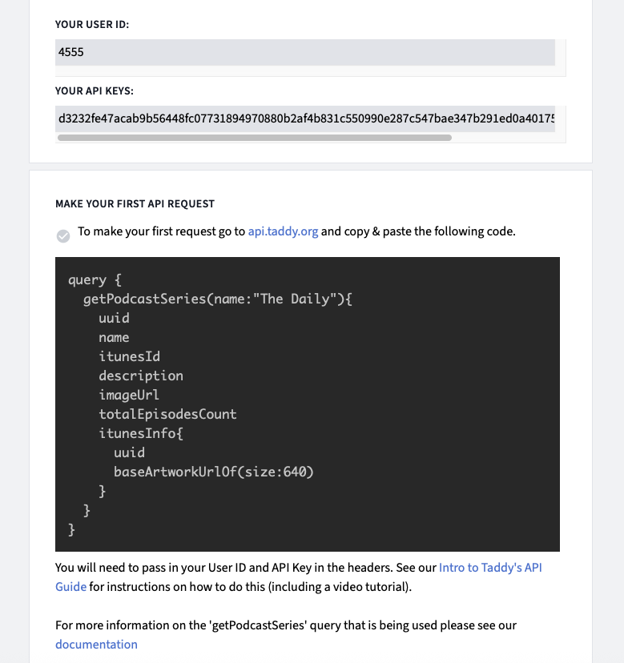
d3232fe47acab9b56448fc07731894970880b2af4b831c550990e287c547bae347b291ed0a401752dce8dbb990c75c77d8
Caption

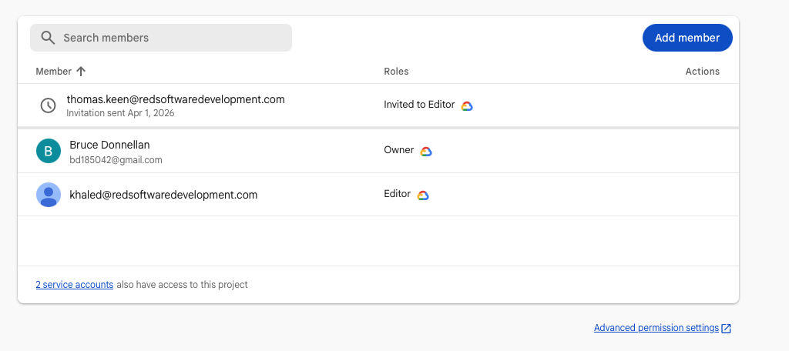
Firebase
Caption

AWS
I have ‘Selected Provide user access to the AWS Management console’
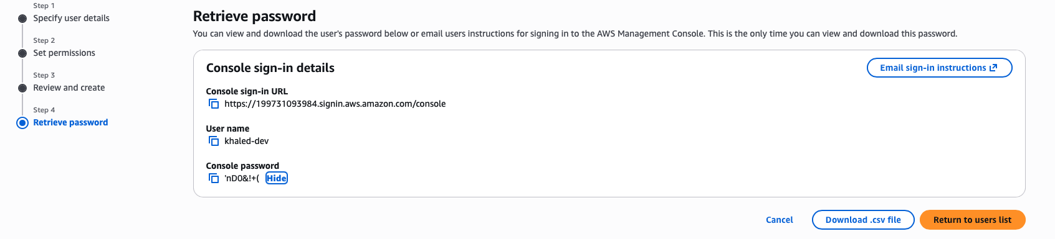
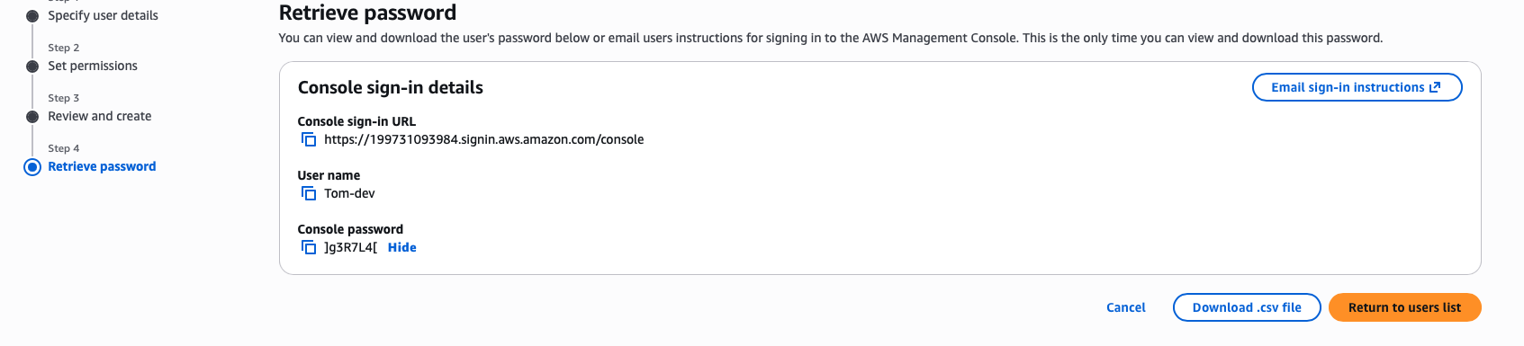
What permissions should I be granting??
Caption
Caption

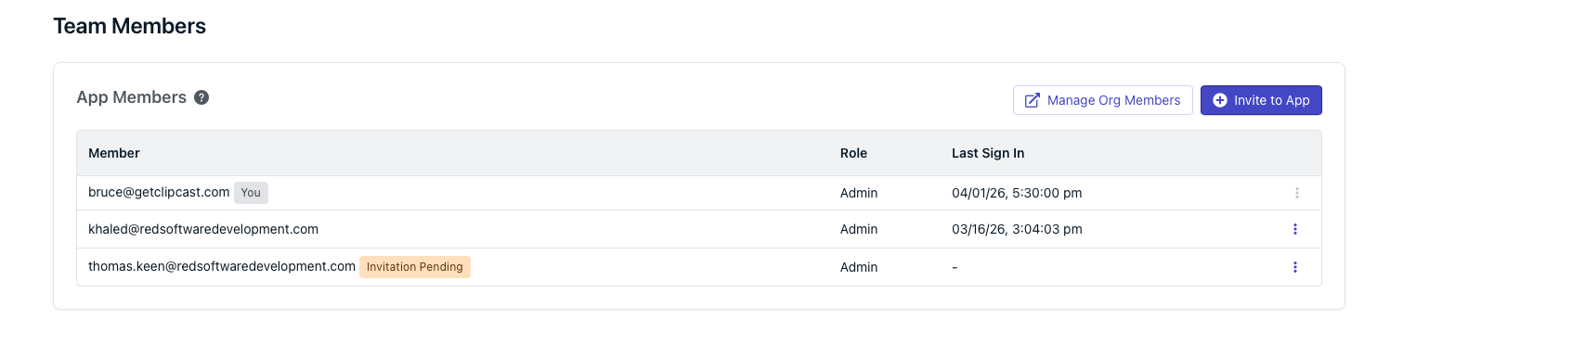
One signal
Caption

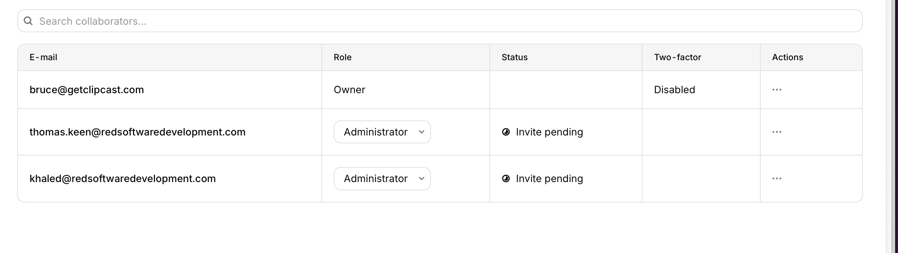
Revenue Cat
Caption

Mixpanel
BOTH INVITES SENT

Resend
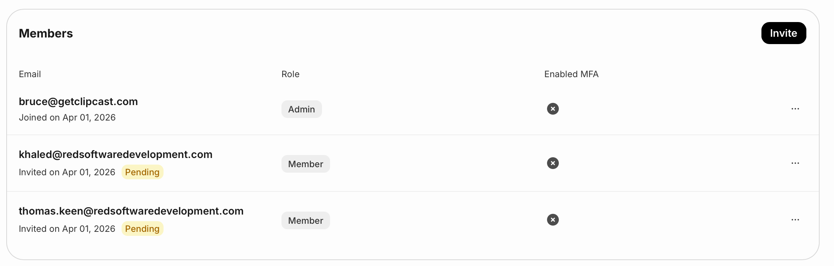
Caption

OpenAI
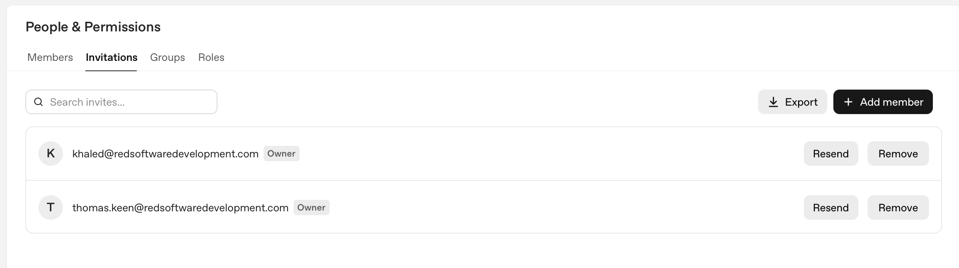
Caption

